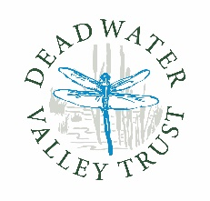

Deadwater Valley Trust
Photography Competition
19th August – 1st October 2021
Entry Form

Name
DOB
If entrant is under 18 parent name
Signature of entrant or parent if under 18 years old | I confirm that I am the entrant and am over the age of 18 or that the entrant is under 18 years of age and I give parental consent for them to enter the Deadwater Valley Trust Photography Competition
Email address
Contact telephone number
Title of photograph

In entering the Deadwater ValleyTrust Photography Competition I accept the terms and conditions of entry as found on the Deadwater Valley Trust website.

Entries can be made in print form – standard postcard size
Black and white or colour
JPEG via email
All entries must have an accompanying form
Entries should be made using the competition postbox outside the Ranger office at The Pheonix Centre or via email to Julie@deadwatervalleytrust.co.uk

